**Sydney Romantics Virtual Internship**

# Task 4:

Flyer:

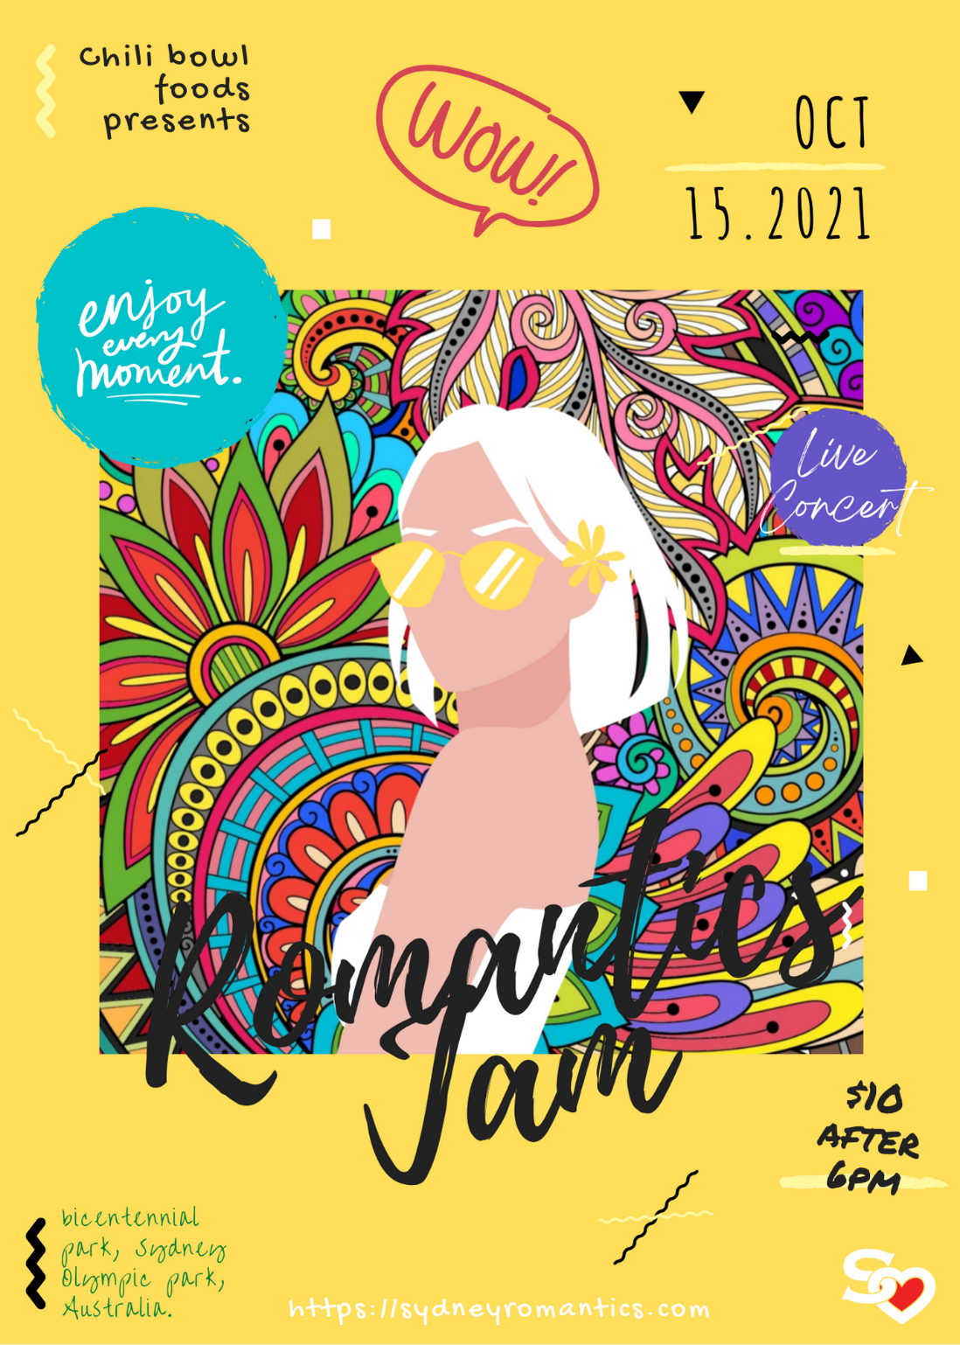

### 2 other creative ways:

1. Banner



1. Instagram Story Ad with swipe up registration link and discount offer

